Thank you for enrolling into the Life Saving Education Holiday Program.

You should have received your booking details including Terms and Conditions and confirmation for each child participating in the program.

Please see below program details:

Location:

****Name and street address***

Look for the flags and shade shelter

General location information / Getting there:

Parking available off ***.

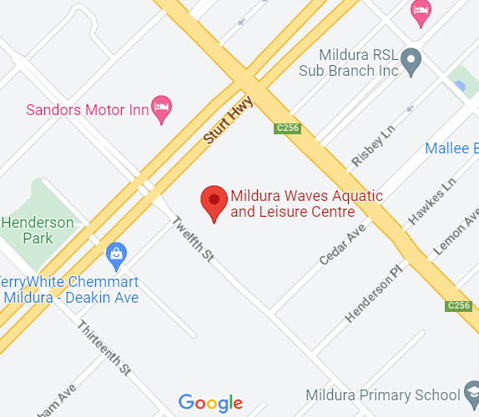

Program Day

Please arrive before your nominated start time to sign-in. Once signed in, you will collect your nipper cap and rash vest. The program coordinator will then bring everyone together to explain how the program will run and introduce you to your instructor.

What should my child bring?

Participants must always have a supervising parent/guardian in attendance with them at every session. Please bring the following:

* Bathers (a ¾ length high visibility rash vest will be provided)
* Wide brimmed hat
* Sunscreen
* Sunglasses
* Drink bottle (labeled)
* Lightweight long-sleeved shirt
* Warm clothing and spare towel (in case of cool weather)
* Enclosed shoes (we strongly recommend enclosed shoes to be worn on the program i.e. water shoes / runners that can get wet).
* Wetsuit (optional)
* Any medication requirements (parent/guardian to have with them)

Expectations of the program and staff:

There will be a program coordinator present to assist with any parent/guardian enquiries. The program will be delivered by instructors with the assistance of water safety personnel.

We will:

* Provide all program equipment
* Provide high visibility pink rash vest and nipper cap
* Promote a Sun safe environment including the use of natural shade and shade shelters (as required), sunscreen and role modelling sun safe behaviour.
* Be respectful of all staff, participants and parents/guardians
* Ensure adequate levels of water safety supervision is in place
* Complete daily risk assessments of the venue and adjust the program as required
* Provide a safe and supportive environment for children and young people, that focuses on fun, education and building confidence

Expectations of participants:

Participants are expected to:

* Meet minimum participant swimming ability evaluations or have parents/guardians discuss participation needs prior to the beginning the program
* Sign in and out each day
* Complete pre-program and post-program surveys for program evaluations (if applicable)
* Stay with their allocated group at all times
* Listen carefully to, and follow, rules and directions as provided by the instructor
* Respect the environment and conditions
* Wear the pink rash vest and cap at all times during the program
* Be sun safe at all times

Expectations of parents/ guardians:

Participants must always have a supervising parent/guardian in attendance to:

* Be prepared in the case of medical or other emergencies (including provision of any medication requirements).
* Monitor participant behaviour
* Supervise toilet visits / changing
* Enforce sun safe practices at all times
* Be respectful of all staff, participants and parents/ guardians
* Encourage participants to have fun while gaining water safety knowledge and skills
* Ensure the participant is signed in before each day’s program and signed out before departing the program (must notify instructors if removing child from the group).
* Complete pre-program and post-program surveys for program evaluations (if applicable)
* We encourage parents to actively contribute to the running of the program. If you would like to assist, please provide your Working with Children Check (Volunteer) details which must also be with you on the day.
* Tasks may include; assisting to set-up / pack-up equipment, moving equipment between activities.
* Water education and swimming is hungry work. We suggest that you have some healthy snacks (fruit, trail mix etc) available for your child at the end of the session.

Contacts

For any questions regarding registrations please contact:

**<<Key contact name>> <<Key contact name>>**

**<<Key contact mobile>>** **<<Key contact mobile>>**

We look forward to seeing you by the water!

Kind regards,

The LSV team, <<enter your name and any delivery partners here>>