



RRCongratulations

First name Surname

**On participating in the Life Saving Education Program**

**with Life Saving Victoria and \*\*\***

January 2025

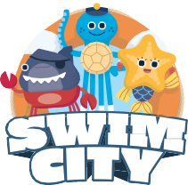



**Looking for more? Learn water safety from home with Swim City!**