Dear Parent/Guardian,
We are excited to announce the revitalisation of the Royal Life Saving Swim and Survive program! The refreshed Curriculum has been mapped to the National Swimming and Water Safety Framework which provides national benchmarks for children’s swimming and water safety competencies.
We will be introducing the new curriculum here at <Insert Swim School name> from <Insert date>
The new curriculum includes four infant levels and twelve general Swim and Survive levels.
Infant Levels – Little Wonders
There is one curriculum for Infant children aged 6 months to 3 years. The Little Wonders level now includes more parent/carer education which will help parents understand the skills, methods and reasoning.
Level four of the Little Wonders levels is a ‘transition level’. The aim of the transition level is to assist children progressing to independence in the water without parents or carers. The level also allows for greater skill progression along with behavioral and social integration to preschool levels.
Swim and Survive levels
There are eleven skill-based levels plus a twelfth level equal to the Bronze Star. Level 1 – 3 in the Preschool program and Levels 1 – 3 in the Primary School program offer the same curriculum.
This enables:
- Clear progressions throughout the curriculum
- Clear alignment between preschool and school aged levels
- Easy transition from preschool to school aged levels
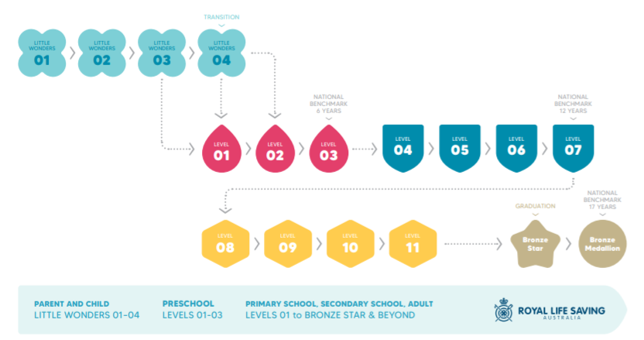
We hope you are just as excited as we are about the revitalised Swim and Survive program and trust that you will continue to enjoy all that it has to offer.

