\

Youth lifesaving pathways handbook:

Welcome to the Youth Lifesaving Pathways Handbook, where our primary aim is to keep Lifesaving Education Program (LEP) participants engaged in lifesaving education throughout their youth fostering a lifelong enjoyment of water safety.

Examples and opportunities throughout this handbook draw from the successful Life Saving Victoria (LSV) Nippers programs with adaptable experiences and opportunities.

We encourage you to work directly with your youth participants to codesign initiatives that will add the most value to your community. See our fast card: My Community – Youth Pathways for a template to include in your program.

For further support, the team can also be contacted on [education@lsv.com.au](mailto:education@lsv.com.au) or (03) 9767 6940.

Overview:

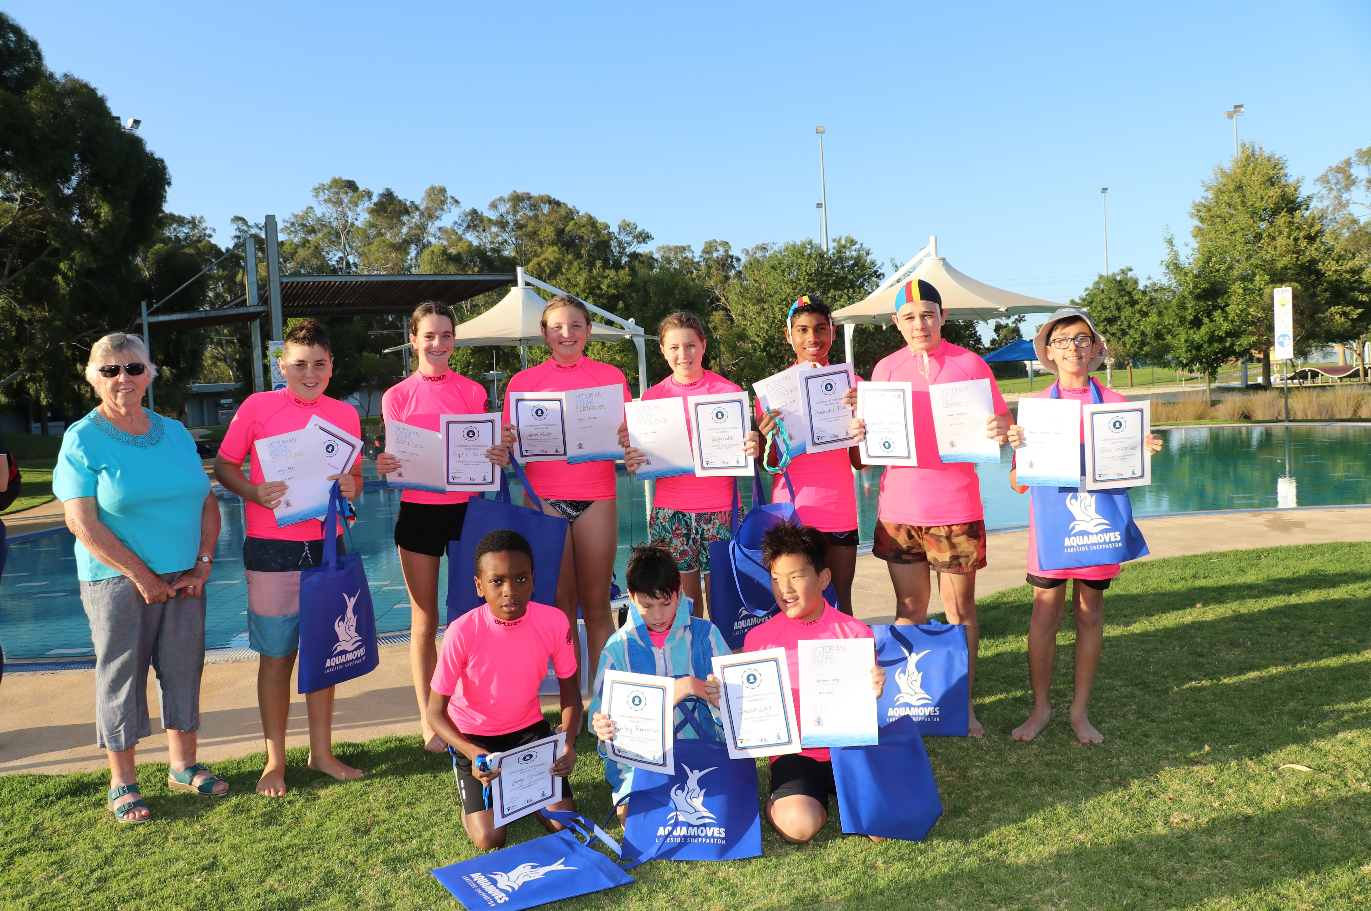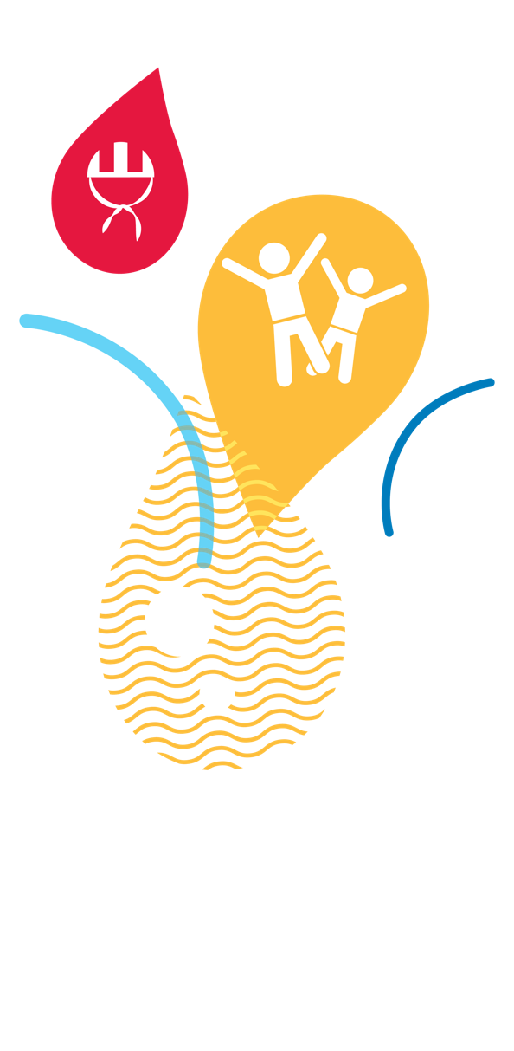

Youth lifesaving pathways

booklet

For lifesaving education

program participants

12+ years



Table of Contents

Youth lifesaving pathways handbook: 1

Forward: 5

Youth development opportunities: 5

Training Pathways: 7

Aquatic Sport: 9

Career Opportunities: 9

Other opportunities around water: 10

Life Saving Victoria respectfully acknowledges the Traditional Owners of the land and waterways in which we swim, explore, play, meet and live.

We acknowledge the Bunurong People and the Wurundjeri People of the Kulin Nation on which this guide was written.

We pay our respects to Elders past and present and celebrate the stories, culture and traditions of Aboriginal and Torres Strait Islander peoples of all communities who also work and live on these lands.

*Image: Painting by Nathan Patterson, a proud Wagiman man. The painting is a tribute to both the traditional custodians of the land and the role lifesaving plays in bringing together and protecting the Victorian community.*

Forward:

This guide has been developed to assist and support youth participants (12-14 years) in choosing their own unique journey in lifesaving: from development in aquatic sports, training, employment and leadership pathways. This handbook contains concise information to assist youth members as they navigate and explore the many opportunities available in lifesaving. We hope it inspires our future lifesavers, swim teacher, pool lifeguards and facilitators to take advantage of the endless opportunities available and work towards their goals and aspirations for a long and fulfilling future in the lifesaving movement.

Your journey through lifesaving is unique. There are many different pathways and areas to explore, develop, learn and grow in. This booklet is intended to guide your lifesaving journey and let it inspire a pathway that will give you an experience of a lifetime.

Youth development opportunities:

From the age of 12, LEP participants can access development, leadership and lifesaving program opportunities. These programs aim to develop both personal skills and extend lifesaving capabilities. Below is an overview to the programs and opportunities that youth participants can access and the prerequisites for involvement. Talk to you LEP coordinator if you are interested in these exciting development opportunities.

Some of the options below are currently available to Life Saving Club/ Surf Life Saving Club members only. To join a life saving club see: [Join A Life Saving Club - Life Saving Victoria (lsv.com.au)](https://lsv.com.au/clubs-members/support/join-a-life-saving-club/)

|  |  |  |
| --- | --- | --- |
| Opportunity | Age requirements | Other requirements |
| **U13 Development Camp** | 12-13 years | 2x places available to LEP participants annually, from an endorsed Partner |
| **Champion Junior Lifesaver Development Day** | 13-14 years | 2x places available to LEP participants annually, from an endorsed Partner (TBC 2026) |
| **Youth Symposium** | 13-17 years | Currently Life Saving Club members only |
| **U15 Leadership Development Camp** | 14-15 years | Currently Life Saving Club members only |
| **U18 Leadership Development Camp** | 16-17 years | Currently Life Saving Club members only |
| **LSVj Youth Symposium** | 13-17 years | Life Saving Club members and Bush Nipper participants |
| **LSV junior (LSVj)** | 14-18 years | 2x members from LSV’s Victorian Learn to Swim Steering Committee junior (TBC 2025) |
| **Victorian Learn to Swim Steering Committee** | 16-18 years | 2x junior committee members 2025 (TBC 2025) |
| **Victorian Learn to Swim Steering Committee junior** | 14-18 years | TBC 2025 |

U13 Development Camp

The U13 Development Camp is an opportunity for youth participants to join life saving club members to develop their interpersonal skills, broaden their understanding of lifesaving and support members as they progress through their lifesaving journey.

Participants are mentored by current outstanding volunteer leaders and have the opportunity to learn, share and network with likeminded lifesavers from across the state over a three day live in camp.

How do I qualify?

* A group of people in life jackets on a paddle board

  Description automatically generatedParticipate in the LEP holiday program (or term based if applicable)
* Be 12 or 13 years of age at the time of the camp
* Be endorsed by your LEP Partner (i.e. facility/ council)
* Interested and excited about meeting members from Victorian life saving clubs
* Keen to learn more about lifesaving and future opportunities

LSVj Youth Symposium

The Symposium will bring together youth members (life saving club members and Bush Nipper / Lifesaving education program participants) from across Victoria for a day in November of much needed connection, fun, and empowerment through delivery of keynote speakers, leadership development activities and a platform to discuss the big issues facing our youth members.

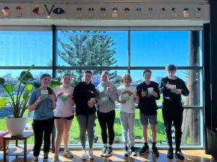The day promises to enrich, challenge and facilitate our leaders of tomorrow with valuable leadership and communications skills. The jam-packed program also features keynote speakers from sport, leadership development and our lifesaving role models. The day will conclude with a development challenge, with our youth members encouraged to design a program or initiative that will help impact an identified need by one of the four executive councils.

Further information will be sent later in the year.

Training Pathways:

Further Training:

Your local facility may deliver any of the below awards, contact them directly to find out more.

|  |  |  |
| --- | --- | --- |
| Opportunity | Age requirements | Other requirements |
| Rescue Strand – Dry Rescue Award | n/a | Nil  Can be achieved in LEP program (Advanced rescues) |
| Rescue Strand – Wade Rescue Award | n/a | Can be achieved in LEP program (Advanced rescues) |
| Rescue Strand – Accompanied Rescue Award | n/a | Nil |
| Bronze Strand – Bronze Star Award | n/a | Nil |
| Bronze Strand – RLSSA Bronze Medallion Award | 14 years | Nil  Advantageous to have senior Swim and Survive and Bronze Star awards. |
| Bronze Strand – Bronze Cross Award | 14-18 years | RLSSA Bronze Medallion Award |
| Advanced Lifesaving – Award of Merit | 15 years | Bronze Cross Award |
| Advanced Lifesaving – Award of Distinction | 16 years | Award of Merit |
| Resuscitation / Emergency Care Strand - Resuscitation Awareness Award |  | Nil  Can be achieved in LEP program (Intermediate Everyday Lifesaver) |
| Resuscitation / Emergency Care Strand – Resuscitation Award | 12 years | Nil  Can be achieved in LEP program (Advanced Everyday Lifesaver) |
| Resuscitation / Emergency Care Strand - Oxygen Resuscitation Award | 14 years | Nil |
| Resuscitation / Emergency Care Strand - Emergency Care Award | 12 years | Nil |

Qualifications:

From the age of 14, youth can book into training courses to extend and develop their lifesaving capabilities and improve employment opportunities. Speak to your local Partner or book directly through [www.lsv.com.au/training](http://www.lsv.com.au/training)

|  |  |  |
| --- | --- | --- |
| Award | Age requirements | Other requirements |
| CPR | 12+ | **Duration:** 3 hours  **Assessments:** Range of theory and practical assessments.  **Update:** Annually. |
| First Aid | 14+ | **Duration:** 1 day.  **Assessments:** Range of theory and practical assessments.  **Update:** Valid for 3 years. |
| Bronze Strand – Bronze Medallion Award | 14+ | **Duration:** 2 full days.  **Pre-requisites:** First aid award and reasonable fitness level and sound swimming ability.  **Assessments:** Range of theory and physical assessments required. Key fitness assessment is a 400m swim in under 13 minutes.  **Update:** Valid for 12 months. |
| Pool Lifeguard | 16+ | **Duration:** 2 full days.  **Pre-requisites:** First aid award and reasonable fitness level and sound swimming ability.  **Assessments:** Range of theory and physical assessments required.  **Update:** Annually. |
| Swim Teacher | 16+ | **Duration:** 1 day plus additional on-the-job training.  **Pre-requisites:** Reasonable fitness level and sound swimming ability.  **Assessments:** Range of theory and practical assessments required. Plus, additional practical assessments required on-the-job. |
| Inland Waterway Lifesaving Certificate | 15+ | **Duration:** 2 full days.  **Pre-requisites:** Reasonable fitness level and sound swimming ability with capability to swim 400m under 9 minutes in a pool.  **Assessments:** Range of theory and physical assessments required. Key fitness component is the run (200m) - swim (200m) -run (200m) in under 8 minutes.  **Update:** Annually. |
| Community Life Saving Certificate | 15+ | **Duration:** 2 full days.  **Pre-requisites:** Reasonable fitness level and sound swimming ability with capability to swim 400m under 9 minutes in a pool.  **Assessments:** Range of theory and physical assessments required. Key fitness component is the run (200m) - swim (200m) -run (200m) in under 8 minutes.  **Update:** Annually. |
| Mental Health First Aid | Recommended 15+ | **Duration:** 2 full days.  **Assessments:** Range of theory assessments. |
| Marine Licence Training | 12+ | **Duration:** 1 day.  **Assessments:** Multiple choice theory test.  **Update:** 12-month validity to apply for license. |

Aquatic Sport:

Enjoy competition and want a fun way to keep active? Have you considered lifesaving sport opportunities?

Many of our Aquatic Sport carnivals are open to Life Saving Club/ Surf Life Saving Club members only including beach and water, pool, rescue and resuscitation (R&R), surf boat and IRB competitions. To join a life saving club see: [Join A Life Saving Club - Life Saving Victoria (lsv.com.au)](https://lsv.com.au/clubs-members/support/join-a-life-saving-club/)

Below are three opportunities LSV are investigating for our LEP participants.

|  |  |  |
| --- | --- | --- |
| Program | Age requirements | Other requirements / information |
| Junior ‘Come and Try’ Pool Lifesaving Session | 7+ | Currently available to lifesaving club members to try events before participating in the Junior Pool Lifesaving Carnivals |
| Junior Pool Lifeguard Challenge | 14-18 | Send EOIs to *** if you are interested in competing 2026 (competition TBC) |
| Lifesaving Education Inland Waterways Carnival | 8+ | Send EOIs to *** if you are interested in competing 2026 (competition TBC) |
| Pool Lifeguard Challenge |  |  |

Career Opportunities:

There is a wealth of employment opportunities in the aquatics industry. These can be stepping stones to stay in the aquatics industry or develop transferable skills to a variety of careers including sport, teaching, and emergency services.

Start with your local Partner to find out more:

|  |  |  |
| --- | --- | --- |
| Job | Age requirements | Other requirements / information |
| Lifesaving education program instructor | 17+ | Qualifications dependant on location, include partner led opportunities and [LSV direct delivery](https://lsv.com.au/education/join-our-team/) |
| Pool lifeguard (and inland waterways, i.e. Bright River Pool) | 16+ | [Pool Lifeguard](https://lsv.com.au/training-all/pool-lifeguard-training/) |
| Swim Teacher | 16+ | [Teacher of Swimming and Water Safety](https://lsv.com.au/swim-teacher/) |

Other opportunities around water:

Not sure lifesaving is for you but love being around the water? There are so many benefits to being out in nature and especially in blue spaces. Check-in with your local clubs on what they can offer you; participation, sport and competition, development, coaching and employment. A non-exhaustive list below of things you might like to try at your local or holiday aquatic venue:

* [Swimming squads/ club](https://vic.swimming.org.au/)
* [Triathlon](https://www.triathlonvictoria.org.au/)
* Canoeing
* [Kayaking](https://vic.paddle.org.au/)
* Stand-up paddleboarding
* Water skiing
* Jet skiing
* Wakeboarding
* White water rafting
* Rowing
* [Sailing](https://www.sailing.org.au/home/)
* [Fishing](https://www.vrfish.com.au/)
* Power boating
* Water aerobics
* Water polo
* Synchronized swimming
* Synchronized diving
* Underwater hockey
* Underwater rugby
* [Surfing](https://surfingvic.com/)
* [Kite surfing](https://www.kiteboardingaus.com.au/home/)
* Snorkling
* Scuba diving
* Spear fishing
* Other activity providers (i.e. camps and excursions, water parks)